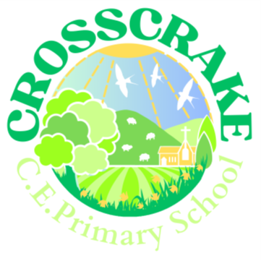
Music development plan summary:
Crosscrake CE Primary School

Overview
Detail | Information
Academic year that this summary covers | 2026-2027
Date this summary was published | October 2026
Date this summary will be reviewed | September 2027
Name of the school music lead | Mrs Mandy Barnsley
Name of school leadership team member with responsibility for music (if different)
Name of local music hub | Westmorland and Furness Music Service
Name of other music education organisation(s) (if partnership in place)

This is a summary of how our school delivers music education to all our pupils across three areas – curriculum music, co-curricular provision and musical experiences – and what changes we are planning in future years. This information is to help pupils and parents or carers understand what our school offers and who we work with to support our pupils’ music education.

Part A: Curriculum music
This is about what we teach in lesson time, how much time is spent teaching music and any music qualifications or awards that pupils can achieve.
At Crosscrake CE Primary School we follow the Charanga schemes. Our class teachers use a mixture of the Creative Music Scheme and the English Model Music Curriculum scheme. Each class has an hour of whole class music teaching each week. Charanga is an excellent platform for delivering class music lessons where learning to read music is encouraged. A balance listening, composing and performing is woven through the scheme.
When we are preparing for a church celebration or school play our music lessons include rehearsing our songs for these events.
Class 4’s music lesson is a First Access whole class instrumental lesson delivered by a member of the Westmorland and Furness Music Service peripatetic team. This year Class 4 are all learning to play the cornet. Our PTFA are funding this exciting project.

Part B: Co-curricular music
This is about opportunities for pupils to sing and play music, outside of lesson time, including choirs, ensembles and bands, and how pupils can make progress in music beyond the core curriculum.
We also have additional instrumental teaching available in our school from the Westmorland and Furness Music Service peripatetic team. This year pupils have taken up flute, clarinet and ukulele. A member of our church community also provides recorder lessons. Guitar is also offered, but there was no uptake this year.
We sing in our daily Collective Worship, choosing a selection of seasonal songs from Come and Praise and the Songs for all Seasons resources. We also use Fischy music to increase our repertoire.
In our Nursery room, singing is included in our daily practise, particularly Nursery rhymes and other popular children’s songs that support our learning. Singing can also be heard in other lessons as a useful learning tool such as the vowel song in our phonics lessons.

Part C: Musical experiences
This is about all the other musical events and opportunities that we organise, such as singing in assembly, concerts and shows, and trips to professional concerts.
Each Summer term we host a whole school music concert where all pupils are encouraged to perform in celebration of their learning. Children who have music lessons outside of school are also invited to perform.
Last year the KS2 children took part in AmaSing at the Coronation Hall in Ulverston. This was a cross-school event organised by Westmorland and Furness Music Service where we performed with a live band.
Each Christmas, our KS2 children attend a local supermarket for Carol Singing.
Our annual school play includes singing, and children are encouraged to perform solos and duets.
Last year the school attended online Musical Mondays, organised by Westmorland and Furness Music Service. This allowed the children to experience a whole variety of world music.

In the future
This is about what the school is planning for subsequent years.
- We plan to take part in Young Voices in the future.
- We plan to continue whole class instrumental lessons from Westmorland and Furness Music Service.
- We will offer further music clubs – such as choir, band and a digital music club.
- We will increase children’s opportunities to experience live music performances

Further information (optional)
Westmorland and Furness Music Service is the lead partner for Cumbria Music Hub. Further information about their work can be found here.
The Department for Education publishes a guide for parents and young people on how they can get involved in music in and out of school, and where they can go to for support beyond the school.

